**Information:**

Interview conducted with Interviewee 5 (female)

36m

Language spoken: English

Automatic transcription done with Zoom Audio transcription, and checked by a coder.

**Follow-up to the survey on the use of machine translation in health contexts**

**Researcher:** Thank you again for accepting to participate in this interview. As you already know, this is a follow-up interview to the questionnaire on the use of machine translation in healthcare in the Netherlands. You replied to this questionnaire earlier this year. Let me start by reminding you that this interview is being recorded. The data collected will be anonymized and analyzed together with other participants’ data. The recording itself will never be published or shared, and it will be deleted as soon as it is transcribed and anonymized. You are free to request a copy of the transcription. In the interview itself, we will invite you to go over potential scenarios regarding the use of technology - specifically, machine translation like Google translate or any other translation system on your phone or device - in healthcare contexts, like when you receive an invitation letter to get vaccinated or when you go to the doctor, huisarts.  The goal is to understand how machine translation can be used and what are the main challenges or opportunities when using it. We aim to create free training for users of machine translation like yourself in order to better support communities in these situations. The scenarios that we will show you are fictitious. They are potential scenarios or stories. The focus is on what you think a person would do if they were in this situation. Discuss anything that comes to mind or that you would like to share. We just ask you not to share confidential information about yourself.  If at any point, during the interview, you feel uncomfortable and you want to pause the interview, please just let us know. We can rephrase the question or stop the interview altogether. You can leave at any point during this interview. Any questions or concerns?

**Participant:** No.

**[STAGE 1 SLIDE 2]**

**Researcher:** I will start now by reading the first scenario that you can also see on the screen.“Two years ago, Maria moved to the Netherlands from Argentina. It was right amid the pandemic, and she moved to take up a position at a new company in Rotterdam. Maria is a native speaker of Spanish, and she also speaks English. She has taken two Dutch courses online, so she understands and speaks rudimentary Dutch. For example, she can ask for a drink or have short conversations with neighbors, but not enough to feel fully comfortable speaking Dutch fluently in all situations. In 2021, she received a letter from the RIVM inviting him to get vaccinated against COVID-19. The letter is in Dutch.” What do you think about this case?

**Participant:** Regarding what?

**Researcher:** Anything that comes across your mind regarding this case.

**Participant:** Cause I mean, I-I identify a lot with the situation, um (pauses), yeah. So it takes a bit more time to understand. You read-you read the keywords and you understand what it's about. And then you say, like, “Okay, after dinner, I’ll take my time, and I’ll use Google translate and see uh, what this means”. So, I guess that’s what I think.

**Researcher:** What do you think Maria can do in this situation with the letter?

**Participant:** I mean, what she can do is many things. I’m assuming, maybe too close to home, that, like, if she leaves alone with nobody that speaks Dutch, or something like that, then they would be- that would be what you could do. I mean, she could do whatever she wants. Ignore it (laughs). She can do…, or ask someone that speaks that fluidly to translate it, or I don't know even, look at the letter and try to understand it first before the translation.

**Researcher:** If you receive a letter from the RIVM in Dutch, what do you do?

**Participant:** I would translate myself, because um (pauses)… In my experience with (pauses) Dutch friends, but uh instead of … reading the letter to you like translating every word by word they just say like “Oh, it means you have to go and get vaccinated” so, and I want to know the full information. So, I would translate it.

**Researcher:** Would you use Google Translate to translate it?

**Participant:** Yes, I-I-II think I'd do that. Yeah, because I don't have the other program.

**Researcher:** Would you use your phone to do that? Or …

**Participant:** : I would type it. I would type it. And possibly because uh, because I (laughs) I’m like this, I would uh save the copy of the translated letter in Word.

**[STAGE 2 SLIDE 3]**

**Researcher: “**Because the letter mentioned COVID-19 and vaccinatie, and Maria had been waiting for more information on when and how she could get vaccinated, it was very important for him to understand the letter completely and thoroughly in all its detail. She tackles this by trying to read the letter top to bottom, sentence by sentence. The letter is hard to understand. She does not know many of the words used, and she feels increasingly nervous.” Why do you think Maria feels this way?

**Participant:** Because you feel (pauses) isolated and uh not knowing what's going on. Maybe you missed something, and that's always a motive for being nervous or anxious.

**Researcher:** Have you ever found yourself in a similar situation?

**Participant:** Yes, then I learned to translate (laughs). I don’t ignore [the letter].

**Researcher:** What would you recommend Maria to do next?

**Participant:** Not ignore it, not wait, uh, but translate, uh, I mean, you can ask a friend, but, as I said before, uh, I would go and translate myself, because, uh, nobody is gonna… Usually people do not take the time to translate everything. So yeah.

**[STAGE 3 SLIDE 4]**

**Researcher: “**Maria decides to use Google Translate. She opens the app on her phone, and using the camera, she scans the letter. It is rather challenging.” How would you say her user experience with the app is?

**Participant:** Challenging (laughs).

**Researcher:** What kind of problems do you think she might face with this technology?

**Participant:** Well, we don't know how old is Maria. It seems she's young and hip uh because she is using this (laughs) uh but um (pauses). So in all honesty I don't know how it works, because I don't use it that often, but I've seen it. I've seen it uh, but I think maybe if the document is too long you have to scan many things, and it's very tiring. I don't know.

**Researcher:** Have you ever found yourself in a similar situation?

**Participant:** Yeah, I prefer to first try to understand, and then what I don't understand. I type it. Also, I don't know if the same, if the same like written thing, you have a top of five thousand words every time [referring to the limit of words to translate in one go], I don't know if the scanner is going to tell this kind of… I don’t know.

**[STAGE 4 SLIDE 5]**

**Researcher: “**Maria is able to make an appointment for her vaccination. On the day of her appointment at the vaccination center, she goes to the counter, where she is asked in Dutch to present her ID and letter of invitation. She manages to understand this because the person on the counter makes a sign of the ID with her hand. Maria is nervous. Next, she is asked to fill in a health questionnaire in Dutch.” What would you recommend Maria to do next?

**Participant:** Ask if they have the questionnaire in English.

**[STAGE 5 SLIDES 6-8]**

**Researcher:** “Because she has some knowledge of Dutch, and the first questions in the form do not appear to be difficult, such as *Naam,* *Achternaam*, Maria tries to answer them in Dutch. On the second page, though, she reads three questions she does not understand. She does not understand questions 11, 12 and 13.”

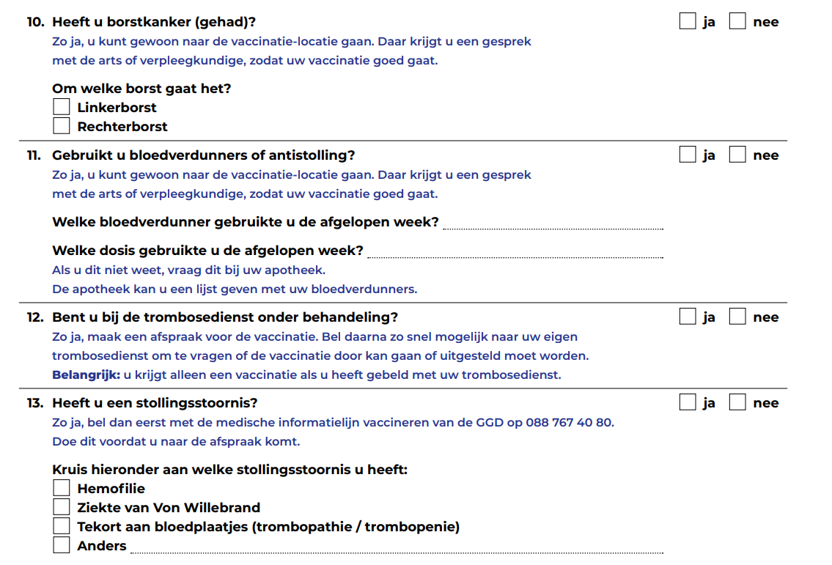

**Researcher:** What would you recommend Maria to do next?

**Participant:** To go to an official there and ask for the translation of the questions.

**Researcher:** Have you ever found yourself in a similar situation?

**Participant:** Yes, but they had precisely for the vaccine, but they had a form in English, so I used that.

**[STAGE 6 SLIDE 9]**

**Researcher:** “Maria asks for help from the young man behind the counter. She asks in Dutch if she can explain what is “bloedverdunners of antistolling”,  “trombosedienst onder behandeling”, and “stollingsstoornis” by pointing at the form with her finger. The young man looks surprised. She looks at the next counter, and it is empty. She looks behind, and everyone seems busy. She then tries to start a sentence a couple of times and finally says in English that these are diseases.”What would you recommend Maria to do next?

**Participant:** You go to an online dictionary (laughs).

**Researcher:** Have you ever found yourself in a similar situation?

**Participant:** Yes, because I know um, I don't know I-I mean I-I read that, and relating to English is like, Oh, bloodthinner, or this, or I have an idea but I want to be sure of what I’m answering, so I would, yeah, try to translate that if the person cannot help me, I would go to the technology. But I would go to the person first.

**Participant:** So you would first go to the person and then you turn to technology. And when you said dictionaries, did you mean a dictionary, like an online dictionary? Or did you mean machine translation?

**Researcher:** I mean, it could be, I mean, if I… if it's only the quote, then- then, because you said that she understands that, but she doesn't, I understand the specific concept, so if there is specific content, I would go to the dictionary. If um just an online dictionary, of course, and and if I don't understand the full question, then I would go to Google Translate.

**[STAGE 7 SLIDE 10]**

**Researcher:** “Maria turns to her phone, opens the Google Translate app, and types the words she does not understand.”In your opinion, is Maria taking a risk by using Google Translate?

**Participant:** At this point in life, no. Or what risk? What do you mean?

**Researcher:** Any risk! Do you think it’s risky?

**Participant:** No, no, it’s okay.

**Researcher:** Did you have something in particular mind?

**Participant:** Yeah, Because I wanted to ask if you, if you mean a health risk like it, like risking, answering wrong or uh risk in terms of her data, or something like looking for this particular, uh, I don't know, looking for blood-thinners and then you’re gonna get ads or the Dutch police, saying “ You want blood-thinners” I don’t know (laughs).

**Researcher**: It could be both, right? How do you see this regarding health and regarding privacy?

**Participant:** Regarding privacy- privacy, I think we're doomed. It doesn't matter, just Google what you had to Google um and um the other matter I think the (pauses), no, I don't I (pauses) I-I don't know, it depends-It depends. Because my mother is a doctor, so I-I-I do understand a little bit of how previous diseases work. But yeah, I have the cultural capital to understand that, so I don't know if uh if someone that really I mean they could just know like, maybe. Sorry, tired. Let me rephrase (laughs) So if they-if they read like blood thinners, and they say like “Oh, okay, no, I’m taking”. They only know the uh, the name of the brand… name of the drug you're taking, and then they don't know that it actually, I don't know aspirin. They take a look at the and then that could be whatever. So now that you mentioned it actually, could be a risk. Uh, but I think I don't, I don't know if the risk is uh amplified by using the translation. Is more, I think, generally like or-or normally, you distributed in terms of like people, don't really know what medication they take.

**[STAGE 8 SLIDE 11-15]**

**Researcher: “**Maria turns to her phone, opens the Google Translate app, and types the words she does not understand.”

We are going to use a scale for the following questions:

5 = to a very high degree

4 = to a high degree

3 = to a moderate degree

2 = to a low degree

1 = not at all

Is the scale clear?

**Participant:** Yes.

**Researcher:** What level of understanding do you think Maria has when using the app? Does Maria understand the text…

5 = to a very high degree

4 = to a high degree

3 = to a moderate degree

2 = to a low degree

1 = not at all

**Participant:** Um, I mean, sorry I’m getting mythological (laughs), if you want me to identify with that and how would I understand it? I think I would say to moderate agree, because there's always-there's always doubt.

**Researcher:** What degree of risk of significant harm is Maria exposed to if using the app? Is Maria’s health at risk?

5 = to a very high degree

4 = to a high degree

3 = to a moderate degree

2 = to a low degree

1 = not at all

**Participant:** I would say to a low degree, and I (pauses) would, and because I think she is exposed to all the other Dutch speaking people that don't really understand about-anything about medication.

**Researcher:** What degree of trust should Maria have in these translations? Should Maria trust these translations?

5 = to a very high degree

4 = to a high degree

3 = to a moderate degree

2 = to a low degree

1 = not at all

**Participant:** From-from Dutch-she’s translating, this is important though, from Dutch to English or from Dutch to her mother tongue?

**Researcher:** Does that change your perception of trust?

**Participant:** Yes, on the-on the previous things also because I think the translation from Dutch to English and vice versa it's much more reliable than uhn in other-I mean, not. Spanish-Spanish is probably very good, because yeah, it's also a language very spoken, and also like in the Internet super big, uh, but I would say, if it's a minority language, I would be more distrustful. Uh a very little spoken language, because also because of machine learning how it works (laughs) I think, like the the pull the thing up to draw uh, to to translate uh, that would be uh smaller. So I think Maria speaks Spanish as I do as mother tongue, so I think to a high degree. I would trust the translations, uh the either to Spanish or English.

**Researcher:** What degree of vulnerability do you think Maria has while using the app? Is Maria at risk of being vulnerable?

5 = to a very high degree

4 = to a high degree

3 = to a moderate degree

2 = to a low degree

1 = not at all

**Participant:** Hhm. Vulnerable (pauses). Is that all? Uhm, uhm, to the people around her? To the-to the?

**Researcher:** Whatever perception you have about being vulnerable in this situation she is in. She is at the vaccination center, she has this questionnaire in Dutch in front of her, she does not know these words.

**Participant:** Hmm. Well, of course, I mean always like not being able to fully communicate with your surroundings make you-makes you more vulnerable. So she's already at a lower degree than let's say that her peers that do speak Dutch well. Um, um so (pauses) but while using the app uh, I think it makes you a bit more vulnerable to the people around you, people notice that you don't know your way around things they can be, I guess, more rude to you or not really uh help you a lot, uh, or, on the contrary, be very helpful, because they see that you don't know what the hell is going on so. Uh, but yeah, I mean, we're using the app (reads question again) think, just to- no, yeah, but I would say to a moderate degree, though, because um, it's important that these are just three questions that you put in that you said like she doesn't understand. But if the thing, if the questionnaire or whatever she has to do is longer, then, uh uh, people around her will likely lose their patience, uh and uh, that makes you more vulnerable because you wanna be heard, you wanna be understand, understood, and you wanna understand what you're doing. So uh, yeah, to a moderate degree.

**Researcher:** Are there any other comments about this scenario or related scenarios you can think of?

**Participant:** Uh, (pauses) uf, yeah, I think the (pauses) well I've had I-I would say, yeah, very uh difficult experiences, um, I mean not exactly like this, but like with doctors actually being able to communicate in English and everything, but really not uh being open, not wanting to help um, not to help. But I don't know. I've seen a lot of people have a lot of trouble with mental health, and I actually had to bring a friend to a mental health facility. It was really difficult. I was there just, I mean, because he was alone, so no family. I was there trying to support him and asking for help and everything. And-and it's a-yeah, it depends. Basically, the problem that I see is not only that the like, the information is not available in English given that this is a country that actually calls for expats and students from everywhere, And blah blah! So, even though, that I’m highly educated, and I know, like I have all the privilege, I've had to like, really kind of be rude to be heard, or something like that which is really not what I want to do, but people treat you like, Uh yeah, your concern is not very important or not very worthy if you don't speak Dutch, or if you try to speak Dutch, and you speak Dutch wrongly, they say like “Oh, oh, what you meant”. It's like, yeah, we're in the context of this. Of course, I've meant that, of course my pronunciation is not the best, but I’m trying here. So they wanna… Yeah, they want to switch to English if your Dutch is not perfect, but also when you switch when you.. they also don't speak English perfectly, and then I don't know… everything takes more time, it's more frustrating, and I think the translation app is really useful for things that you have the time to you-you can take the time to understand, for example, letters at home and this kind of things. But when interacting with people, for example, when Maria in this case had to go to the facility, then uh that takes maybe double of the time that it would take to uh ask a question, and uh, some things get lost in translation, making people more vulnerable. And also, yeah, people are just. I don't sometimes a little bit, um (pauses) racist (laughs).

**[Training - follow-up questions – SLIDES 16-17]**

**Researcher:** Before we end the interview, we also wanted to ask you what sort of training on using these machine translation apps you would find helpful.

What type of information on machine translation would make your life easier when using these apps in health contexts?

For instance, do you feel you need more instructions on how to use the apps? Can you give us an example?

What about information about how to deal with the translations themselves? Do you have an example?

Would it be helpful to understand better the instances when machine translation is not advisable?

**Participant:** Uhm, maybe (pauses) I guess the whole package of like, which are the apps available uh what works better for what like, uh, maybe like, yeah, for long text, use this for short things use that. Um (pauses) um, and (pauses) yeah, this tips like, I don't know. If, like you have to do it to English instead of I mean, I do that because I think it's better, but I don't I I don't know, maybe it's not uh so uh, should I? Yeah, should I translate it to English, and then uh, understand? So if I don't understand English, then translate English to Spanish, or doing directly from Dutch to English. What like? What are those recommendations?

**Researcher:** How would you like access to more information to make using these apps easier?

For instance, would you prefer to have short videos on a website or YouTube, step-by-step guides, or infographics?

Would you prefer to be offered free in-person training? And where?

If there was a website with infographics and videos explaining how to use these apps better, would you find that helpful?

**Participant:** I think, use of videos, no I don’t. But I mean I’m old school, but uh. I probably would probably like infographics, I think that's really nice, like a nice design with the information. Um, and maybe uh links where to go for more information, and so like the highlights uh there, and where to go for more, I guess, and training, of course, but I can. I do, this is really out of my field, so I don't imagine I cannot imagine what that is, and so I don't know if I would be interested if I see a leaflet like go the training. Probably I would, but uh, but I don't. I don't really know. So-so I-I would go to. I would go to a-a thing but if it says machine translation, I-I-I-I don't think I mean even for me, that's like what what's that? Uh, and I know, so I would say, just use a simple language, remind people like just translation apps and um and uh, yeah, and I think I would do that. Yeah, if it's yeah, either. I mean, I-I work at the university, so I would go if it's in university, but maybe for other people I don't know. I would also love to go to something that is my neighbourhood, for example.

**[Closing]**

**Researcher:** Thank you for participating in our research. Our times of analysis and publication are long, but feel free to write to us to obtain the results of this research. Otherwise, we will contact you with the results in due time.